WEEKLY ASSIGNMENT-2 DEBUGGING EXERCISE
const customers = [
{ id: 1, name: "Ravi", age: 32, policy: "Health", premium: 4800, active: true },
{ id: 2, name: "Anita", age: 51, policy: "Life", premium: 12000, active: true },
{ id: 3, name: "Kiran", age: 28, policy: "Vehicle", premium: 3500, active: false },
{ id: 4, name: "Meena", age: 45, policy: "Health", premium: 6000, active: true },
{ id: 5, name: "Suresh", age: 60, policy: "Life", premium: 18000, active: false }
];

1.for (let i = 0; i <= customers.length; i++) {
console.log(customers[i].name);
}

for (let i = 0; i < customers.length; i++) {
console.log(customers[i].name);
}



2. const activeCustomers = customers.filter((c) => {
c.active === true;
});

const activeCustomers = customers.filter((c) => {
return c.active === true;
});
Console.log(activeCustomers);
When we use { } in an arrow function,we must explicitly return a value.
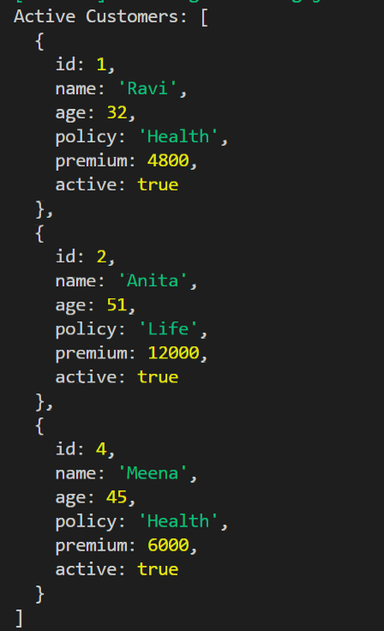

3.const updatedPremiums = customers.map((c) => {
if (c.age >= 50) {
c.premium = c.premium * 1.1;
}
});

const updatedPremiums = customers.map(c =>
c.age >= 50? { ...c, premium: c.premium * 1.1 }: c
);

console.log(updatedPremiums);

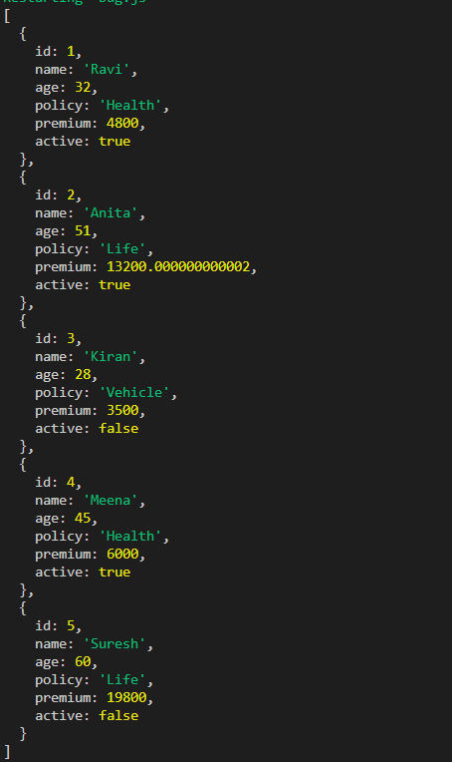

4. const totalPremium = customers.reduce((total, c) => {
total + c.premium;
}, 0);

const totalPremium = customers.reduce((total, c) => {
return total + c.premium;
}, 0);
console.log(`Total Premium: ${totalPremium}`);

5.console.log("Customer ${customers[0].name} has policy
${customers[0].policy}");

console.log(`"Customer ${customers[0].name} has policy
${customers[0].policy}"`);


6. const policyCount = customers.reduce((count, c) => {
count.policy = (count.policy || 0) + 1;
return count;
}, {});

const policyCount = customers.reduce((count, c) => {
count.policy = (count.policy || 0) + 1;
return count;
}, {});

7.const customersWithRisk = customers.map((c) => {
let riskLevel;
if (c.age < 35) riskLevel = "Low";
if (c.age <= 50) riskLevel = "Medium";
else riskLevel = "High";
return { ...c, riskLevel };
});

const customersWithRisk = customers.map(c => {
let riskLevel;
if (c.age < 35) {
riskLevel = "Low";
} else if (c.age <= 50) {
riskLevel = "Medium";
} else {
riskLevel = "High";
}
return { ...c, riskLevel };});


8. let active = 0,
inactive = 0;

for (const c in customers) {
if (c.active) active++;
else inactive++;
}

let active = 0,
inactive = 0;

for (const c of customers) {
if (c.active) active++;
else inactive++;
}

9. const getLifeCustomers = () =>
customers.filter((c) => c.policy === "Life").map((c) =>
c.name);

const getLifeCustomers = () => {
return customers.filter((c) => c.policy === "Life").map((c) =>
c.name);}

10. const sortedCustomers = customers.sort((a, b) => b.premium -
a.premium);
ans:

const sortedCustomers = [...customers].sort(
(a, b) => b.premium - a.premium
);
